**Computer Networks**

**Experiment 1**

**Name: Rohit Deshpande**

**Roll No: 16010122041**

**Batch: TY COMPS A2**

**____________________________________________________________________________**

Networking Devices: A Comprehensive Report

**1. Hub**

A hub is a fundamental networking device used to connect multiple computers or other network devices within a Local Area Network (LAN). Operating at the physical layer (Layer 1) of the OSI model, a hub is known for its simplicity and basic functionality.

Hubs function as a central connection point for network devices. When a data packet arrives at one of its ports, the hub broadcasts the packet to all other ports. This means that every device connected to the hub receives the packet, but only the intended recipient processes it. This broadcasting method can create a lot of unnecessary network traffic and can lead to data collisions, making hubs inefficient for larger or more complex networks.

In Day to Day life, hubs can be found in small home networks or older office setups where network traffic is minimal. For example, in a small office with a few computers and a printer, a hub can be used to connect these devices. However, with advancements in networking technology, hubs have largely been replaced by more efficient devices such as switches.

From an engineering perspective, hubs are straightforward devices with limited intelligence. They do not filter data or have the capability to route data packets based on addresses. Hubs are typically used in star network topologies, where each network device is connected to the hub. While they are not ideal for high traffic networks, hubs are useful in situations where simplicity and cost effectiveness are priorities. The simplicity of hubs makes them easy to set up and maintain, but their inability to manage traffic effectively means they are rarely used in modern networks.

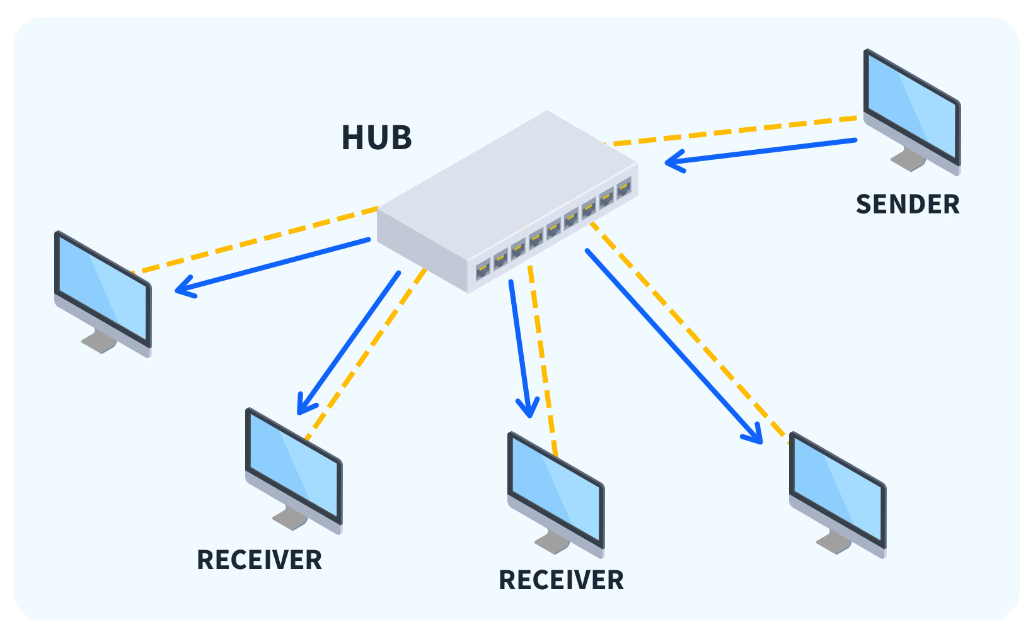

**2. Repeater**

A repeater is a network device that regenerates and amplifies signals to extend the distance they can travel. Operating at the physical layer (Layer 1) of the OSI model, repeaters are essential in maintaining the integrity of data over long distances.

Repeaters receive incoming signals, clean them of noise and distortion, and retransmit them at a higher power level. This process ensures that signals remain strong and clear over extended distances, preventing data loss and degradation. Repeaters are particularly useful in large networks where signals need to travel over long cables or through multiple buildings.

In Day to Day life, repeaters are commonly used in wireless networks to extend WiFi coverage. For example, in a large home or office, a WiFi repeater can be placed at a midpoint between the router and the area where the signal is weak. This setup ensures a strong and reliable WiFi connection throughout the entire space. Repeaters are also used in telecommunication networks to extend the range of telephone signals, allowing for clear voice communication over long distances.

From an engineering standpoint, repeaters are critical in scenarios where long distance communication is necessary. They are used in fiber optic networks to regenerate light signals, ensuring high speed data transmission over vast distances. In copper based networks, repeaters help maintain signal quality over long cable runs. The placement of repeaters is crucial; they need to be strategically located at intervals that maximize their effectiveness without causing interference. The use of repeaters can significantly improve network performance, especially in environments where signal attenuation is a concern.

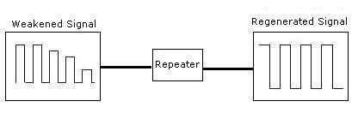

**3. Bridge**

A bridge is a network device that connects two or more network segments, improving communication and efficiency within the network. Operating at the data link layer (Layer 2) of the OSI model, bridges play a crucial role in segmenting and managing network traffic.

Bridges function by filtering traffic between network segments based on MAC addresses. When a data packet arrives at a bridge, it examines the destination MAC address and determines which segment the destination device resides in. The bridge then forwards the packet only to the appropriate segment, reducing unnecessary traffic and collisions. This selective forwarding enhances the overall performance and efficiency of the network.

In Day to Day life, bridges can be used to connect different floors of a building. For instance, in a multi story office building, each floor can have its own network segment connected by a bridge. This setup allows devices on different floors to communicate seamlessly while keeping local traffic isolated to each floor. Bridges are also useful in connecting wired and wireless network segments, ensuring that devices on both types of networks can communicate effectively.

From an engineering perspective, bridges are essential in creating efficient and scalable networks. They help reduce collision domains, which in turn minimizes network congestion and improves performance. Bridges can also be used to connect different network topologies, such as Ethernet and token ring networks, enabling smooth communication between diverse systems. Modern bridges often come with additional features like Spanning Tree Protocol (STP) to prevent network loops and enhance reliability. By segmenting a large network into smaller, manageable pieces, bridges make network management and troubleshooting more straightforward.

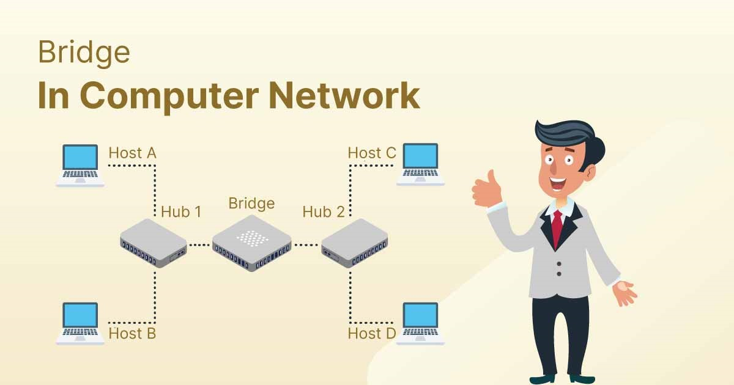

**4. Switch**

A switch is a network device that connects multiple devices within a network, using MAC addresses to forward data to the correct destination. Operating primarily at the data link layer (Layer 2) of the OSI model, switches are integral to modern network infrastructure.

Switches operate by creating a separate collision domain for each connected device, significantly reducing the likelihood of collisions. When a data packet arrives at a switch, it examines the destination MAC address and forwards the packet only to the port where the destination device is connected. This targeted forwarding reduces unnecessary traffic and enhances overall network performance. Some switches, known as Layer 3 switches, also perform routing functions, making them versatile in handling both switching and routing tasks.

In Day to Day life, switches are ubiquitous in both home and enterprise networks. For example, in a home network, a switch can be used to connect a computer, printer, smart TV, and gaming console to the internet. In larger enterprise environments, switches are used to connect servers, workstations, and other network devices, forming the backbone of the network infrastructure. Managed switches with advanced features are commonly used in data centers and corporate networks to ensure optimal performance and security.

From an engineering standpoint, switches offer advanced features such as Virtual LANs (VLANs), Quality of Service (QoS), and port mirroring. VLANs allow network administrators to segment a physical network into multiple logical networks, improving security and traffic management. QoS ensures that critical applications receive the necessary bandwidth for optimal performance, which is essential in environments with voice, video, and data traffic. Port mirroring enables network monitoring and troubleshooting by duplicating traffic from one port to another for analysis. These features make switches highly versatile and essential in modern networking.

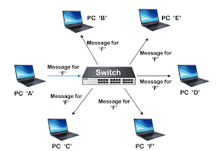

**5. Router**

A router is a network device that connects different networks and directs data packets between them. Operating at the network layer (Layer 3) of the OSI model, routers are crucial for managing data traffic and ensuring efficient communication across networks.

Routers determine the best path for data to travel from the source to the destination based on IP addresses. They use routing tables and protocols like OSPF, BGP, and RIP to make informed decisions about packet forwarding. Routers also provide network address translation (NAT), allowing multiple devices on a local network to share a single public IP address. Additionally, routers can offer firewall services, protecting the network from unauthorized access and malicious traffic.

In Day to Day life, routers are most commonly found in homes and offices to connect local networks to the internet. For example, a home router connects devices like computers, smartphones, and smart home gadgets to the internet. In businesses, routers connect different branch offices, enabling seamless communication and data exchange. Advanced routers used in enterprises and data centers manage large volumes of traffic and provide robust security features to protect sensitive data.

From an engineering perspective, routers are sophisticated devices with extensive capabilities. They use various routing algorithms and protocols to ensure data packets take the most efficient path to their destination. Routers can also perform traffic shaping, bandwidth management, and load balancing to optimize network performance. In large scale networks, routers are deployed in a hierarchical structure, with core routers handling high speed backbone connections and edge routers managing access to the network. This hierarchical setup enhances scalability, reliability, and performance in complex network environments.

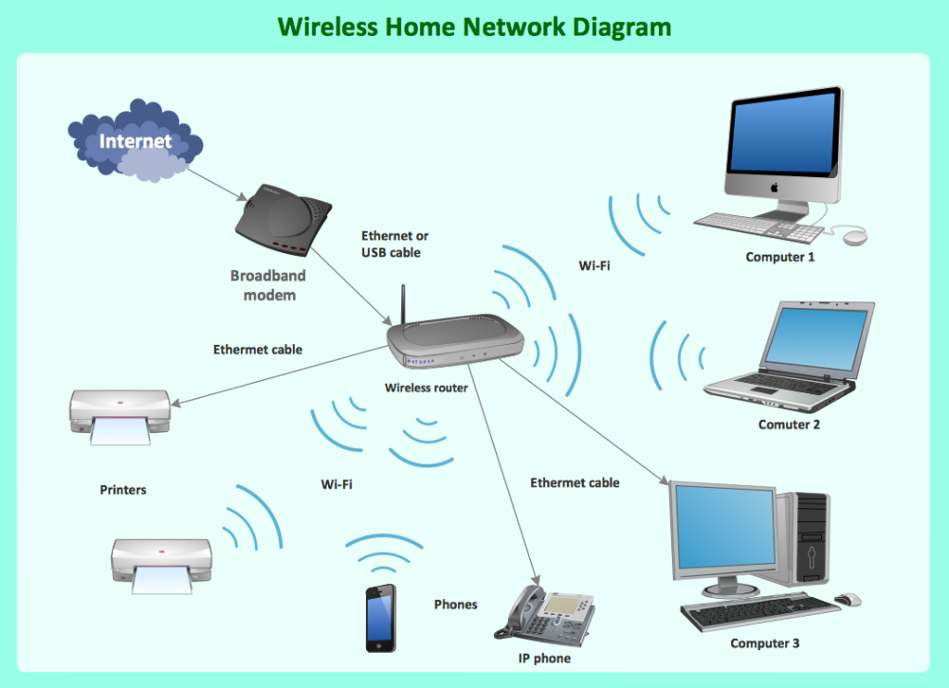

**6. Gateway**

A gateway is a network device that acts as a bridge between different networks, often with different protocols. Gateways operate at various layers of the OSI model, typically at the application layer (Layer 7), enabling communication between heterogeneous systems.

Gateways perform protocol conversion, allowing devices on different networks to communicate effectively. For example, a gateway can translate data from a TCP/IP network to a network using a different protocol. Gateways can also provide security features such as filtering unwanted traffic, monitoring data transfers, and ensuring secure communication between networks.

In Day to Day life, gateways are used in a variety of scenarios. For instance, in a Voice over IP (VoIP) setup, a gateway connects traditional phone systems to IPbased networks, enabling voice communication over the internet. Another example is in IoT (Internet of Things) environments, where a gateway can connect various smart devices, each potentially using different communication protocols, to a central network for unified management and control.

From an engineering perspective, gateways are critical in environments where different systems need to communicate seamlessly. Gateways handle complex tasks such as protocol translation, data format conversion, and managing traffic between disparate networks. For example, in industrial automation, gateways are used to connect legacy systems with modern IoT devices, enabling real-time monitoring and control of manufacturing processes.

In the context of cloud computing, gateways facilitate secure and efficient data transfer between on-premises infrastructure and cloud services. They can implement advanced security measures, such as encryption and authentication, to protect sensitive data during transit. Gateways also play a crucial role in ensuring interoperability between different vendors' equipment, making them indispensable in multi-vendor network environments.

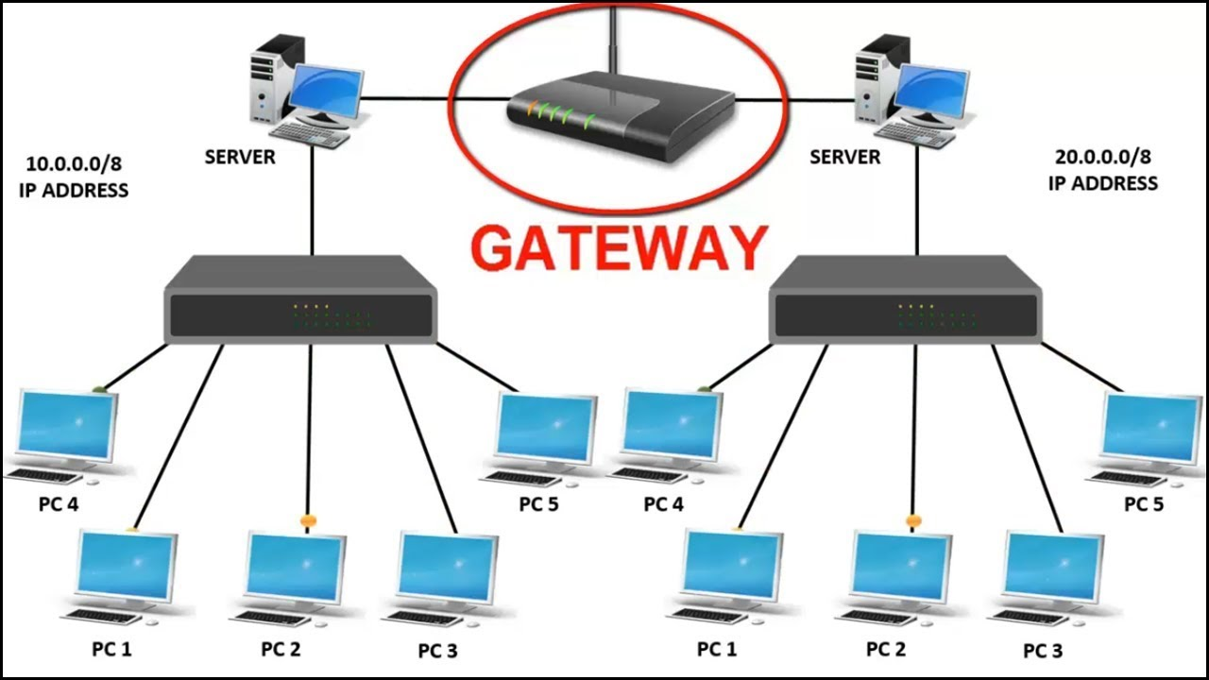

**Transmission Media**

### **Guided Transmission Media**

#### **Introduction**

Guided transmission media refer to the physical means through which data is transmitted from one device to another using a solid medium. The data signals are directed along a specific path, which makes guided media reliable and efficient for data communication. This category includes twisted pair cables, coaxial cables, and fiber optic cables, each with its unique characteristics and applications.

#### **Types of Guided Media**

1. **Twisted Pair Cables**:
   * **Description**: Comprising pairs of insulated copper wires twisted together, this medium minimizes electromagnetic interference (EMI) from external sources and crosstalk between adjacent pairs.
   * **Variants**: There are two types: Unshielded Twisted Pair (UTP) and Shielded Twisted Pair (STP). UTP is commonly used in Ethernet networks, while STP offers better protection against EMI.
2. **Coaxial Cables**:
   * **Description**: Coaxial cables consist of a central conductor, an insulating layer, a metallic shield, and an outer insulating layer. This structure provides better shielding against EMI and allows higher bandwidth than twisted pair cables.
   * **Applications**: Widely used in cable television systems, broadband internet connections, and other applications requiring robust and reliable data transmission.
3. **Fiber Optic Cables**:
   * **Description**: These cables use light signals to transmit data through strands of glass or plastic fibers. They offer exceptionally high bandwidth and are immune to electromagnetic interference.
   * **Advantages**: Fiber optic cables support long-distance communication with minimal signal loss and are ideal for high-speed data transmission in backbone networks and data centers.

#### **Examples in Day-to-Day Life**

In everyday life, guided transmission media are integral to various applications:

* **Home Networks**: Ethernet cables (twisted pair) are used to connect routers, computers, and other devices within homes.
* **Television and Internet**: Coaxial cables are the standard medium for delivering cable TV and broadband internet services.
* **Telecommunications and Data Centers**: Fiber optic cables form the backbone of telecommunications infrastructure and are essential for high-speed internet connections and data center operations.

#### **Engineering Aspects**

From an engineering perspective, guided media offer several advantages, including higher data rates, reliability, and reduced susceptibility to interference. Engineers select the appropriate type of cable based on the application's requirements, considering factors such as distance, bandwidth, and environmental conditions. Installation and maintenance practices are crucial to ensure optimal performance and longevity of the transmission medium.

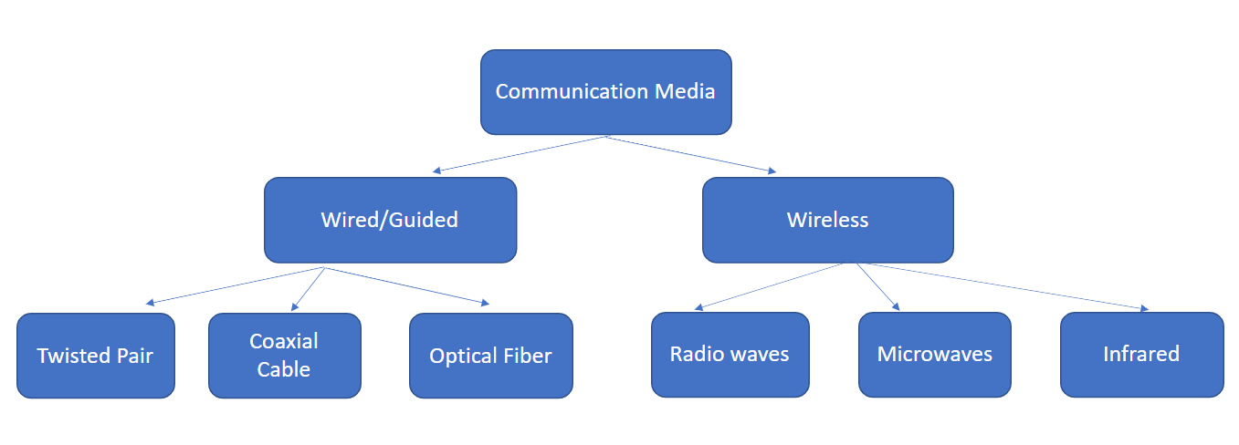

### 

### **Unguided Transmission Media**

#### **Introduction**

Unguided transmission media, also known as wireless media, facilitate data transmission without a physical conduit, using electromagnetic waves to carry signals through the air or space. This category includes radio waves, microwaves, and infrared waves, each with its unique properties and applications.

#### **Types of Unguided Media**

1. **Radio Waves**:
   * **Description**: Radio waves are a type of electromagnetic wave with frequencies ranging from 3 kHz to 300 GHz. They can travel long distances and penetrate through walls, making them suitable for various communication applications.
   * **Applications**: Commonly used in AM and FM radio broadcasting, television broadcasting, and wireless networking (Wi-Fi).
2. **Microwaves**:
   * **Description**: Microwaves have higher frequencies (1 GHz to 300 GHz) and shorter wavelengths than radio waves. They require line-of-sight transmission and are affected by obstacles like buildings and mountains.
   * **Applications**: Used in satellite communication, cellular networks, and point-to-point communication links.
3. **Infrared Waves**:
   * **Description**: Infrared waves have frequencies between 300 GHz and 400 THz. They are used for short-range communication and require a clear line of sight.
   * **Applications**: Commonly used in remote controls, infrared data transmission (IrDA), and certain wireless peripherals like keyboards and mice.

#### **Examples in Day-to-Day Life**

Unguided transmission media are pervasive in everyday life:

* **Wi-Fi Networks**: Radio waves enable wireless internet access in homes, offices, and public places.
* **Cellular Communication**: Microwaves are essential for mobile phone networks, allowing voice and data communication over long distances.
* **Remote Controls**: Infrared waves are used to operate televisions, air conditioners, and other electronic devices remotely.

#### **Engineering Aspects**

From an engineering standpoint, designing and deploying unguided transmission media involves considerations like signal strength, interference, and bandwidth. Engineers must account for factors such as the environment, distance, and the presence of obstacles to optimize wireless communication. Technologies like spread spectrum and MIMO (Multiple Input Multiple Output) are employed to enhance the performance and reliability of wireless systems.

